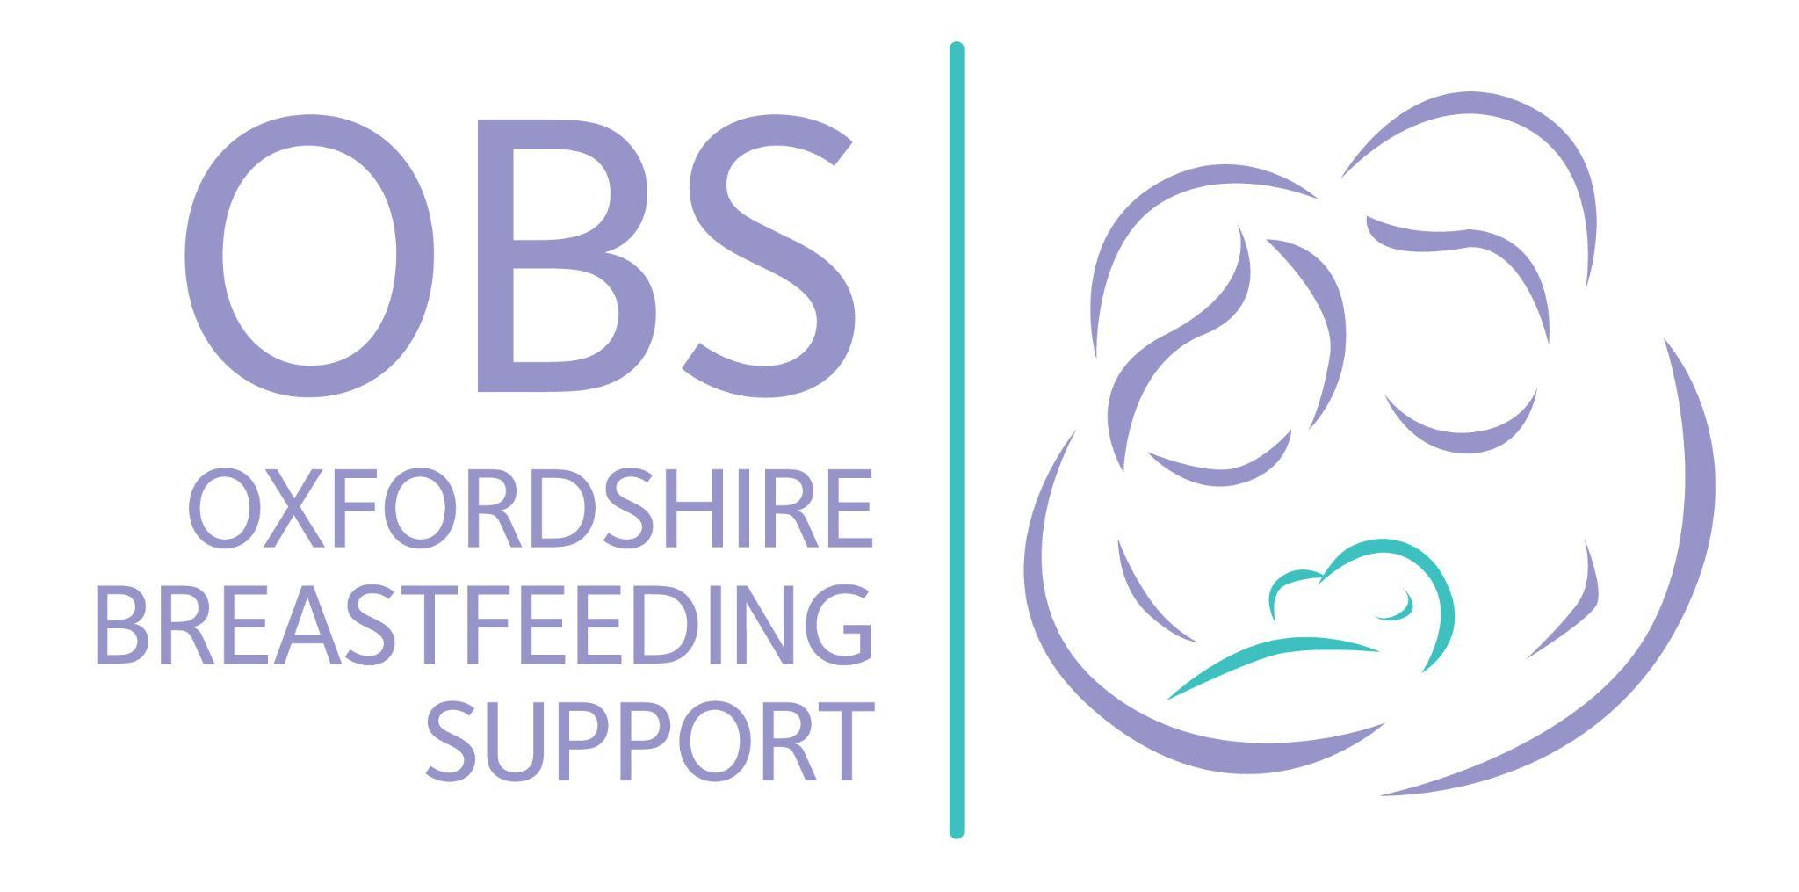

Oxfordshire Breastfeeding Support - FAQs

Summary
Oxfordshire Breastfeeding Support (OBS) is a small breastfeeding support charity established in 2018. Our dedicated team of specialist breastfeeding support facilitators and volunteers provide vital assistance to families in Oxfordshire, enabling them to breastfeed their babies and children. We strive to build an integrated network of breastfeeding support throughout the county. Our inclusive approach embraces diverse feeding choices, offering non-judgmental support and evidence-based guidance.

Who are we?
With a history stretching back locally to 2006, Oxfordshire Breastfeeding Support (OBS) was set up to provide support to families living in Oxfordshire to enable them to breastfeed their babies and children. The service is delivered by a small team of specialist breastfeeding support facilitators who are assisted by our trained volunteers.

How do we connect with you?
- Facebook Page: @OXBreastfeedingSupport
- Friends of OBS Facebook Page: @FriendsofOBS
- Twitter/X: @OxBreastfeeding
- Instagram: @oxbreastfeeding
- Website: www.oxbreastfeedingsupport.org.
- Email: team@oxbreastfeedingsupport.org

What’s our vision and mission?
Our vision is a world where everyone gets the breastfeeding support they need. We seek to develop an integrated network of breastfeeding support throughout Oxfordshire, so that all parents can access skilled, timely, local breastfeeding help.

What are our values?
We wholeheartedly embrace and respect the diverse feeding choices of every parent, whether exclusively breastfeeding, mixed feeding or pumping. We provide a nurturing and non-judgmental environment that meets individuals where they are on their feeding journey. We offer unwavering support and evidence-based guidance, ensuring that each parent feels respected, empowered, and equipped to make informed decisions that best serve their family's well-being.

What do we do?
We support approximately 1,000 Oxfordshire families each year to breastfeed their babies and children. Support is provided through weekly in person group sessions, one to one video consultations, a Facebook group, a monthly Preapring to Breastfeed workshop and low cost breast pump hire. In addition, we offer tailored support to teenage mothers in partnership with specialist health visitor service - the Family Nurse Partnership. We also provide valuable learning and observation opportunities to student healthcare professionals and a low-cost breast pump loan scheme.

How are we funded?
As an independent charity, we rely on charitable grants, trusts, foundations, and generous contributions from philanthropists. We also conduct our own fundraising campaigns to sustain our vital services.

Where are our in person sessions?
We deliver weekly support sessions across Oxford in East Oxford, Barton and Kidlington. We are in the process of setting up a new session in the Leys and also run a weekly session in Didcot.

Who are our partners?
In addition to those previously mentioned, we collaborate closely with midwives, health visitors, the infant feeding team at John Radcliffe Hospital in Oxford, as well as various local groups and charities providing breastfeeding support within the county. Our active involvement extends to a county-wide breastfeeding support strategic group, and we also have partnerships with community and family centres, such as Barton Neighbourhood Association, Kidlinks, and Comper Foundation School.
September 2023

