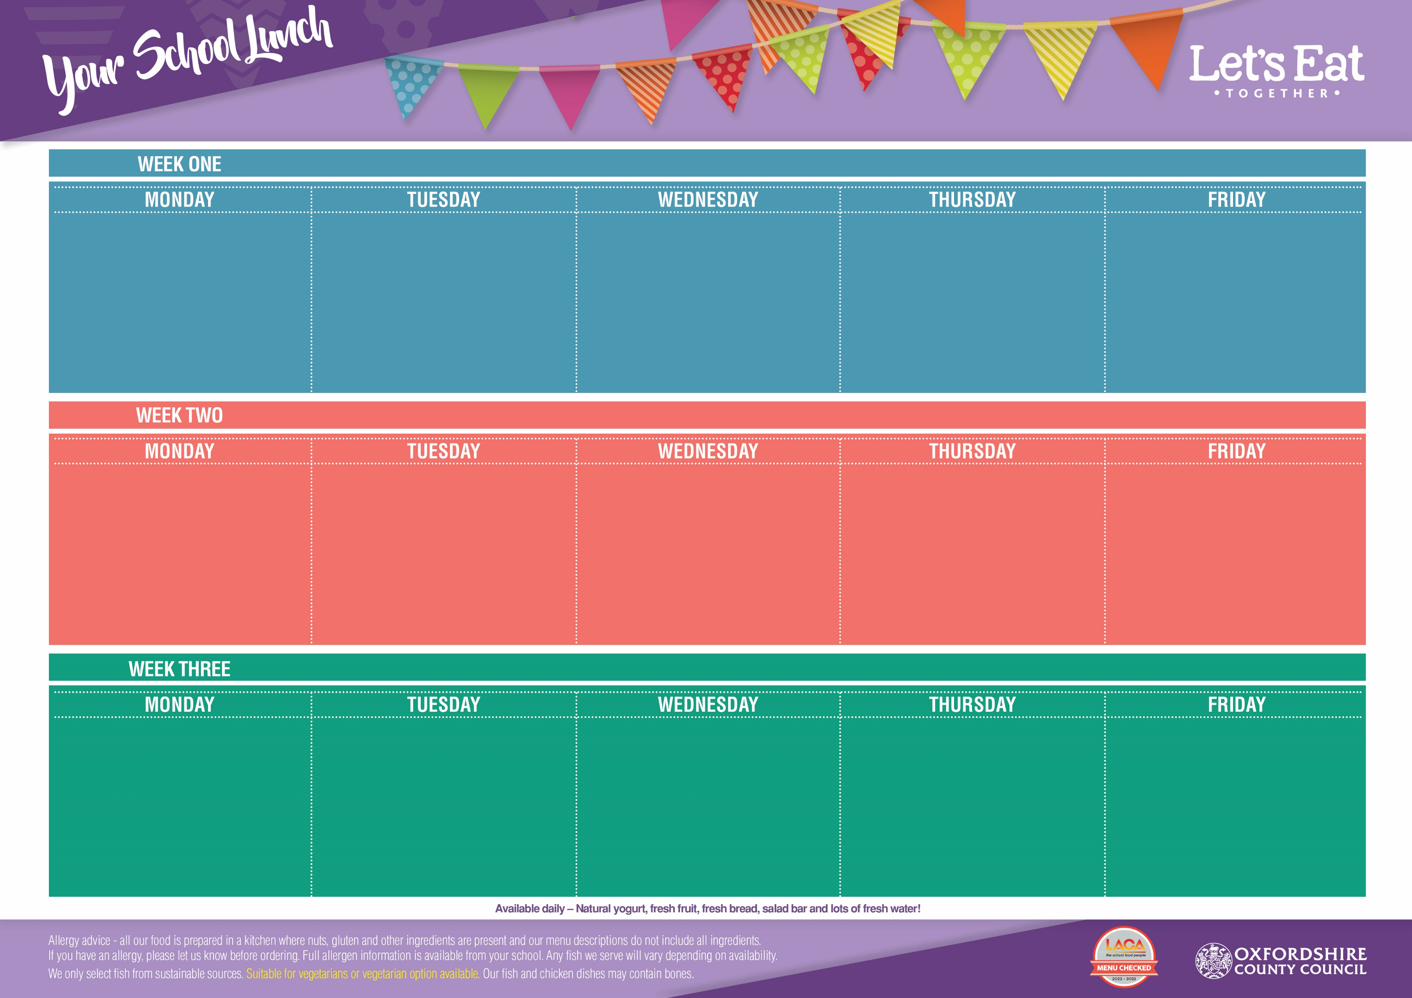

Flipper Dippers *(DF, EF)*

Veggie Sausage Roll *(VG)*

Free Range Egg Mayo Bap *(V, DF)*

French Fries or Pasta

Baked Beans or Peas

Iced Fruit Smoothie

*(V, GF, EF, DF)*

Mac ’n’ Cheese *(V, EF)*

Mild Veggie Curry with Rice *(VG)*

Oven Baked Jacket Potato with

Boston Beans *(VG, GF)*

Vegetable Medley

& Fresh Green Salad

Crunch Cookie *(V, DF, EF)*

Roast Chicken Breast *(GF, DF, EF)*

Vegetarian Quorn Roast *(V, GF)*

Cheddar Cheese & Tomato Bap *(EF)*

Yorkshire Pudding, Roast Potatoes & Gravy

Cauliflower & Carrots

Melting Moment *(V, DF, EF)*

with Melon

Beef Burger in a Bun *(DF, EF)*

Veggie Burger in a Bun *(V, DF, EF)*

Rainbow Pasta Salad *(VG)*

Sweetcorn & Coleslaw

Sultana & Syrup

Cookie *(V, EF)*

Classic Margherita Pizza (Cheese & Tomato) (*EF, V)*

Cajun Chicken Wrap *(DF, EF)*

Oven Baked Jacket Potato with

Cheese (*V, GF, EF)* or Baked Beans *(VG, GF)*

Peas & Baked Beans

Chocolate & Mandarin Brownie *(V, DF)*

Golden Fish Fingers *(DF, EF)*

Crispy Quorn Dippers *(VG)*

Tuna & Sweetcorn Wrap

*(DF, EF)*

French Fries or Pasta

Baked Beans or Sweetcorn

Shortbread *(V, EF, DF)*

with an Orange Wedge

Moorish Meatballs in a Rich

Tomato Sauce *(GF, DF, EF)*

Veggie Meatballs in a Rich

Tomato Sauce *(VG)*

Oven Baked Jacket Potato with Cheddar Cheese *(V, EF)*

Fluffy Rice, Carrots & Peas

Chocolate Crispie Cake *(V, DF, EF)*

Pork Bangers *(EF)*

Veggie Bangers *(VG)*

Salmon & Cucumber Pasta Pot *(DF, EF)*

Mashed Potatoes & Gravy

Green Beans & Cabbage

Strawberry Jelly *(V, GF, DF, EF)*

with Peaches

Chicken, Tomato & Sweetcorn Pasta

*(EF, DF)*

Cheese & Onion Pinwheel *(V, EF)*

Free Range Egg Mayo & Lettuce Bap *(V, DF)*

Carrots & Broccoli

Ginger Biscuit *(V, EF)*

with Pears

Classic Margherita Pizza

(Cheese & Tomato*) (V, EF)*

Roasted Vegetable Couscous

Salad *(V, DF, EF)*

Oven Baked Jacket Potato with

Cheese (*V, GF, EF)* or Baked Beans *(VG, GF)*

Peas & Baked Beans

Iced Sprinkle Cake *(V, DF)*

Flipper Dippers *(DF, EF)*

Veggie Hot Dog *(VG)*

Tuna & Cucumber Pasta Salad

*(DF, EF)*

French Fries or Pasta

Baked Beans or Peas

Vanilla Ice Cream *(V, GF, EF)*

with Peaches

Turkey & Leek Pie *(DF)*

Chunky Bean & Veggie Chilli *(VG, GF)*

Jacket Potato with Tuna Mayo *(V, EF, DF)*

New Potatoes, Fluffy Rice

Broccoli & Carrots

Lemon Oat Cookie

with Melon

*(V, DF, EF)*

Roast British Gammon *(GF, DF, EF)*

Vegetarian Roast Quorn *(V, GF)*

Power Pasta Salad *(VG,)*

Crispy Roast Potatoes & Yorkshire Pudding with Gravy

Curly Cabbage & Peas

Golden Cornflake

Cookie *(V, DF, EF)*

Beef Bolognaise with Twisty Pasta *(DF, EF)*

Veggie Bolognaise with Twisty Pasta *(VG)*

Cheddar Cheese

& Lettuce Bap *(V, EF)*

Vegetable Medley

& Fresh Green Salad

Flapjack with Raisins

*(V, DF, EF)*

Classic Margherita Pizza

(Cheese & Tomato*) (V, EF)*

Spicy Veggie Burrito *(VG)*

Oven Baked Jacket Potato with

Cheese (*V, GF, EF)* or Baked Beans *(VG, GF)*

Sweetcorn &

Baked Beans

Peach

Sponge *(V)*

**June 17th, July 8th , September 16th , October 7th , November 4th , November 25th , December 16th**

**June 3rd, June 24th, July 15th , September 2nd , September 23rd , October 14th , November 11th , December 2nd**

**June 10th, July 1st, July 22nd, September 9th, September 30th, October 21st, November 18th , December 9th**